- What is playwright?
  - It is a tool to test websites from start to end(the way the user uses the website).
  - Works with all the browsers: Chrome,Edge,Safari,Firefox(Headed and Headless)
  - Works in windows,linux and Mac, can even run tests in CI/CD(jenkins)
  - Can also pretend to be a mobile phone(mobile emulation)
- https://playwright.dev/python/
- Check python at CMD: python –version
- Check pip version: pip –version
- Install playwright:
  - Create a new folder for playwright project: mkdir playwright_demo
  - Change to directory: cd playwright_demo
  - Create a virtual environment: python -m venv venv1
  - Need to activate: venv1\scripts\activate
  - Install playwright: pip install playwright and playwright –version
To upgrade: pip install playwright -U
  - Can also install using pytest: pip install pytest-playwright
  - Install browser binaries: playwright install
Downloads Chrome, Firefox and Webkit for testing
  - Verify installation: python -m playwright –version
- Create a new python file and install python extension for vs code in extensions
- Sequence of understanding the code:
  - Import playwright
  - Start playwright
  - Launch browser
  - Open tab
  - Visit website
  - Get title
  - Close browser
- Run the code: python .\Firsttest.py

How to use Pytest:
- Difference between playwright and pytest-playwright

Playwright Playwright with pytest
- Core playwright API - pip install pytest-playwright
(includes browser automation (Adds pytest integration – fixtures, CLI support)
API and bindings) - This installs the pytest plugin for playwright
- Write tests using pytest structure
- Use fixtures like page, browser etc without
manually launching the browser
- Easily run tests with pytest command
- pytest is a framework for python – it is used to
Write simple, scalable and readable test cases.
- Pytest-playwright gives test structure and automation convenience
- .\venv1\scripts\activate
- Pip list
- Pip install pytest-playwright
- Playwright install
- Playwright –version
- Pytest –version
- Pip list
- Pip show pytest-playwright – complete information
  - https://github.com/microsoft/playwright-pytest
- Run the pytest: pytest .\test_google.py
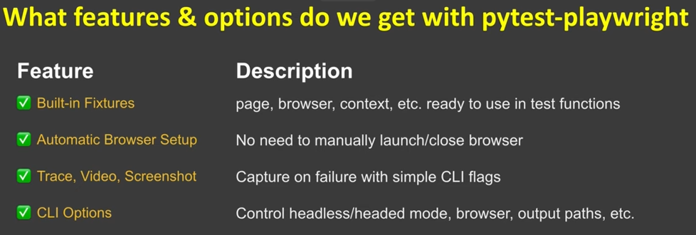

What is a test in pytest?
- A test is just a function whose name starts with test_
- Pytest automatically finds and runs these functions
pytest .\test_google.py –headed
- Capture screenshot: pytest .\test_google.py --browser=chromium --headed --screenshot=on
- Record video: pytest .\test_google.py --browser=chromium --headed --screenshot=on --video=on
- Can also generate html file after installing pytest-html and add options –html=report.html
  - Pip install pytest-html
  - Pip list
  - Pytest --help

